Hear ye, hear ye, all Captains & Crew!

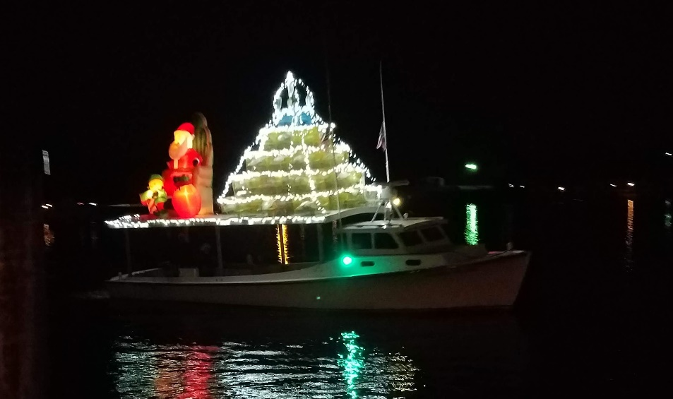

The annual Solomons Lighted Boat Parade will be held at 6:30 pm Saturday, December 5th, weather permitting, during the Solomons Christmas Month (no walk this year instead different events throughout December). This year’s parade will be hosted by the Solomons Business Association (SBA), the Solomons Island Yacht Club (SIYC), Solomons Yachting Center (SYC), Zahniser’s Yachting Center (ZYC), Sail Solomons and the Patuxent River Sail and Power Squadron (PRSPS).
All boats, of any size, shape or make, are most welcome. Come out and show the Solomons community your holiday spirit by decorating your boat. All that is required is to decorate your ship’s starboard side, decorate more if the moment strikes you. Awards will include: Best in Show, First Prize, Second Prize., Third Prize, and Honorable mention. There will be a junior division as well. Boats will be judged on: Technical Merit, Creativity, Theme, Crew Involvement, and Overall Presentation. This year’s theme is Santa’s Workshop.
A captain’s meeting will be held at 5:45 at the Dock office at the Yachting Center covering the route of the parade, safety issues, and the rules for judging immediately prior to the parade. Captains, please ensure that your boats are at the facility prior to the start of the meeting. A dock master will be available to aid in docking. Call on VHF channel 09 for further instructions. Judging will be at SIYC a change from last year’s location.
The awards will be made as usual at the Club immediately following the parade. If you would like to dock at the Club please contact either Dennis Chandler or Tony Baratta to arrange a slip.
Our Social Committee is planning an event to coincide with the parade and give everyone a front row seat at the parade. Let’s beat out the competition and be the best boat parade on the Bay. Let’s go all out this time.

